

FRONT END – PART 1
BOOTSTRAP

(Feedback Form)

In this activity, you will be exploring Bootstrap 5 documentation. You have to create two simple feedback forms.
1. Using Modal component
2. Using Offcanvas component
The modal component was also present in Bootstrap 4, but the offcanvas component was newly introduced in Bootstrap 5. Head over to this link to read about it: https://getbootstrap.com/docs/5.0/components/offcanvas/

Note: You may require an additional
styles.css file to add personalised styling
like padding, margin, etc. Also, attach the
CDN link for Bootstrap 5.

Follow the below steps:
1. Go to the bootstrap documentation to fetch the code for the modal component and alter it to produce the desired result as shown:
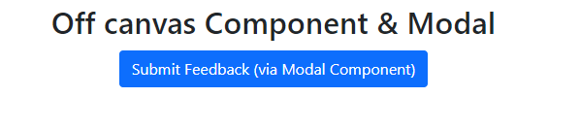
When you click on ‘Submit Feedback (via Modal Component)’, a modal should appear like this:
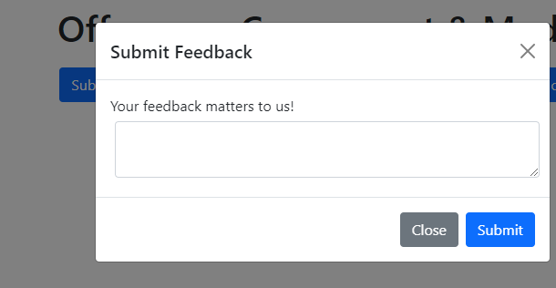
2. Go to the documentation to fetch the code for an Offcanvas component and alter it to produce the desired result as shown:
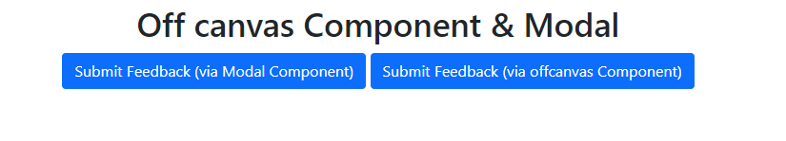
When you click on this button, it opens the offcanvas component from the left side of the screen with the following content. (Hint: Alter the content within <div class="offcanvas-body"> this div to create the desired feedback form.)




